Dear Gents,

Have a nice day, find here the new structure of HR in the coming version which server holding companies:

Currently each branch has their own separate employees, the employees cannot work in more than one branch or seen by different branches, this design not serving holding company which has HR department want to see all the employees of the company, calculate the salary for each branch and post it to its related GL account.

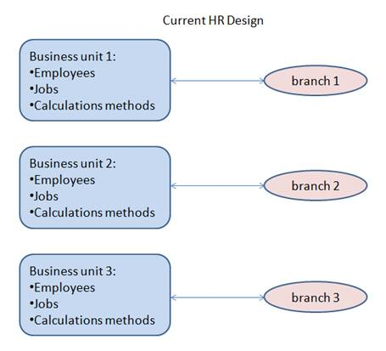

Problem solving in coming version by new HR redesign structures:

HR structure redesigned to server holding company better and at the same time server the company that want to work separately for each branch.

The new design allow us to create group of business unit encapsulated by their own data:

* Employees
* Jobs
* Grades
* Department structure
* Calculation rules

This group of business unit can be assigned to one or more branch, so all its encapsulated data (employees, jobs, calculation rules, …. ) can be seen by different branches assigned to it:

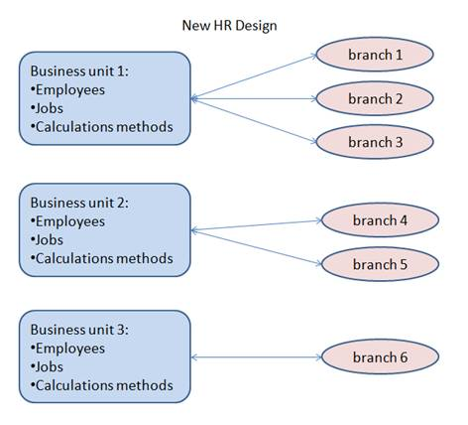

In this new design we define the employees data only once and assign the employees to more than one branch, the employee can change the company they work on it each month and its related salary will be calculated and loaded to its related company accounts.

In this solution we don’t create account mapping or cost center mapping and we don’t create legal person for each employee

How to implement this design in bright coming version:

1. Assign each branch to each related business unit as shown:

In this example I create

* HR business group called ‘HR Branch 1’ and assigned it ‘Branch 1’ and ‘Branch 2’
* HR business group called ‘HR Branch 3’ and assigned it ‘Branch 3’

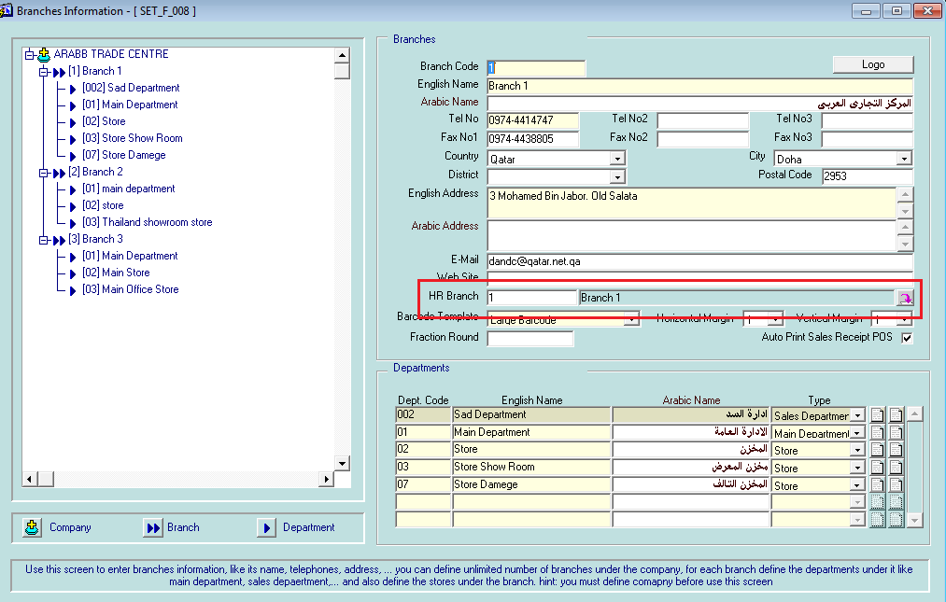

1. create the employees, jobs, grades,…. of  business group ‘HR branch 1’  which can be seen by both ‘branch 1’ and ‘branch 2’
2. create the employees, jobs, grades,…. of  business group ‘HR branch 3’  which can be seen by only ‘branch 3’

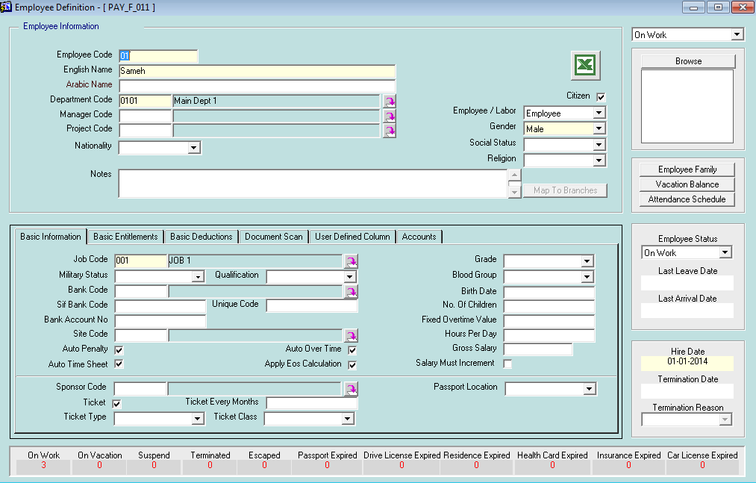

3-  create the department structure for each HR business unit 1 and 2 and mapping this to their related branch

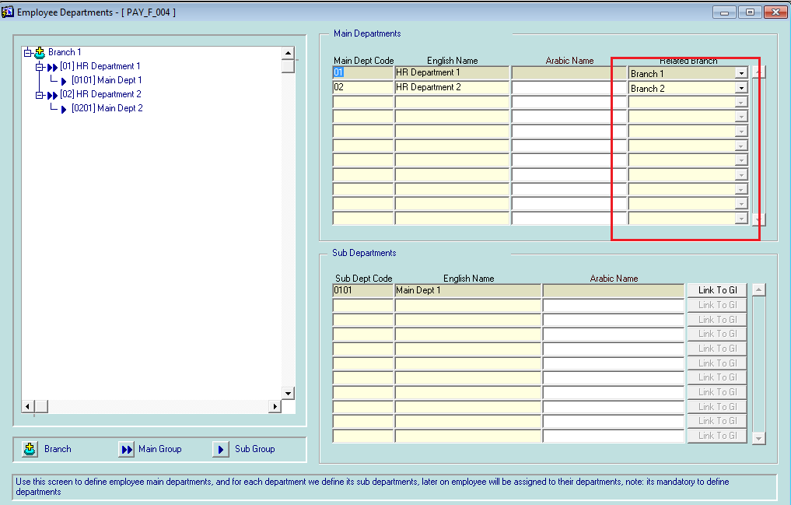

                4- we can change the employees department any month and its salary will be loaded to its related branch automiatically

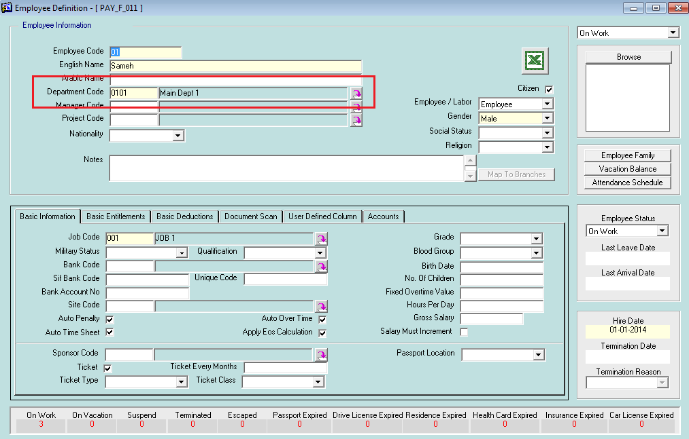

                5- we can calculate and post the salary of each branch separately

